Chapter 7, Solution 43.

Before t = 0, the circuit has reached steady state so that the capacitor acts like an open circuit. The circuit is equivalent to that shown in Fig. (a) after transforming the voltage source.
40 
0.5i
2 A
80 
i
0.5i
v_{o}
(a)
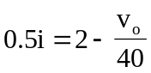, 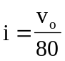
Hence, 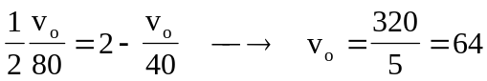
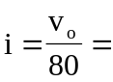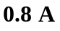

After t = 0, the circuit is as shown in Fig. (b).

0.5i
80 
i
v_{C}
(b)
0.5i
3 mF
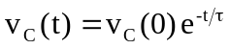, 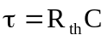

To find 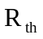, we replace the capacitor with a 1-V voltage source as shown in Fig. (c).
0.5i
80 
i
v_{C}
(c)
0.5i
1 V

+
−

 